Serving Physicians Since 1926
Broward County Medical Association

BCMA Membership

Value and Benefits

The BCMA represents physicians and affiliated healthcare professionals dedicated to serving their patients and community by protecting the integrity of the practice of medicine.  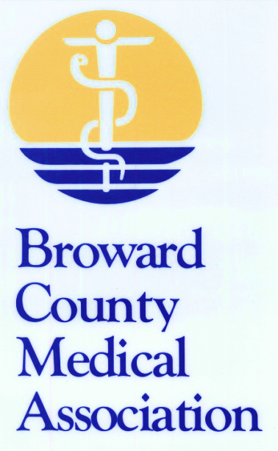  5101 N.W. 21st Avenue, Suite 450  Fort Lauderdale, Florida 33309  Phone: 954-714-9772  Fax: 954-714-9289  Email: cpeterson@bcma.com  Web: www.bcma.com | ADVOCACY and  GRASS ROOTS LOBBYING  The BCMA informs local legislators on key state and national legislative issues that impact physicians and their patients in conjunction with the AMA and the FMA. |  | PRACTICE MANAGEMENT  BCMA routinely communicates with Medicare and insurance companies regarding physicians’ economic and enrollment issues. BCMA supports the physicians’ office staff with answers to their day-to-day problems.
 | REFERRALS  BCMA provides the public with information about member physicians’ credentials, address, and telephone number. |  | MEDICAL LIABILITY INSURANCE  With the BCMA’s Group Program, members receive a 5% discount on their premiums.
 | BAMPAC  (Broward Allied Medical Political Action Committee) Works via voluntary contributions from physicians and their spouses to support pro-medicine candidates. |  | WORKERS COMPENSATION INSURANCE  Through the BCMA’s Group Program with OptaComp, members receive up to 24.8% of their premium back in the form of a dividend.
 | VENDOR PROGRAMS  The BCMA saves physician members time and money through a variety of discount programs and partnerships. From medical malpractice insurance to document shredding, the BCMA finds ways to decrease your expenses while continuing to practice medicine. |  | LEADERSHIP & NETWORKING OPPORTUNITIES  The BCMA hosts various events where members can connect with other physicians and leaders in the healthcare industry to help shape the future of the practice of medicine.
 | SPEAKERS BUREAU  The BCMA provides members the opportunity to inform the public about healthcare issues by providing local organizations with speakers for their meetings. |  | COMMUNICATIONS  Physicians receive information on key issues via fax or email. THE RECORD, BCMA’s official journal, provides a wide variety of key information for physicians.
EDUCATION
BCMA holds seminars on the latest practice management information and state mandated CME programs.

BCMA Membership Application*
Payment Information
Payment Must Accompany Application |  |  | □ Visa |  | □ MasterCard |  |  |  | □ American Express |  |  |  |  | □ Check (Payable to BCMA)
Amount |  | □ $150 (New Member) |  |  |  |  | □ $225 (Second Year) |  |  |  |  | □ $350 (Third Year On: Active Member)
 |  | □ $150 (Maxillofacial Surgeon) |  |  |  |  |  |  |  |  | □ $150 (Doctor of Podiatric Medicine)
Card # |  |  |  |  |  |  |  |  |  |  |  |  | Expiration Date |  |  |  | Security #
Name on Card (Please Print) |  |  |  |  |  |  |  |  |  | Signature
Billing Address | Street Address
 | City |  |  |  |  |  |  |  |  |  |  |  |  |  | State | Zip
Membership Information (Please fill out form completely)
Name |  |  |  |  |  |  |  |  |  |  |  |  |  |  |  | Today’s Date
Medical License # |  |  |  |  |  |  |  |  |  | Group/Practice Name
Office Address | Street Address
 | City |  |  |  |  |  |  |  |  |  |  |  |  |  | State | Zip
Office Phone |  |  |  |  |  |  |  |  |  | Office Fax
E-Mail |  |  |  |  |  |  |  |  |  | Web Site
Specialty |  |  |  |  |  |  |  |  |  | Sub Specialty
Applicant Date of Birth (required for credentialing) |  |  |  |  |  |  |  |  |  | Spouse’s Name
How did you hear about us?
How would you like to receive correspondence from the BCMA? |  |  |  | □ Fax # |  | □ Email |  | Please list preferred # or address
Please fax or email application with credit card information completed or mail with check enclosed. Thank You.
New Membership applications will be presented for approval at the next Board of Directors meeting at the end of the month.
*An application does not constitute automatic membership in the BCMA.
5101 N.W. 21st Avenue, Suite 450 Phone: 954-714-9772
Fort Lauderdale, Florida 33309 Fax: 954-714-9289
Web: www.bcma.com Email: cpeterson@bcma.com

